Aws Auto scaling:

Step 1: We need to create the AMI (to take application instance backup).

Step 2: We need to create the launch-configuration from AMI

Step a: we need to choose the Ami and click on select.

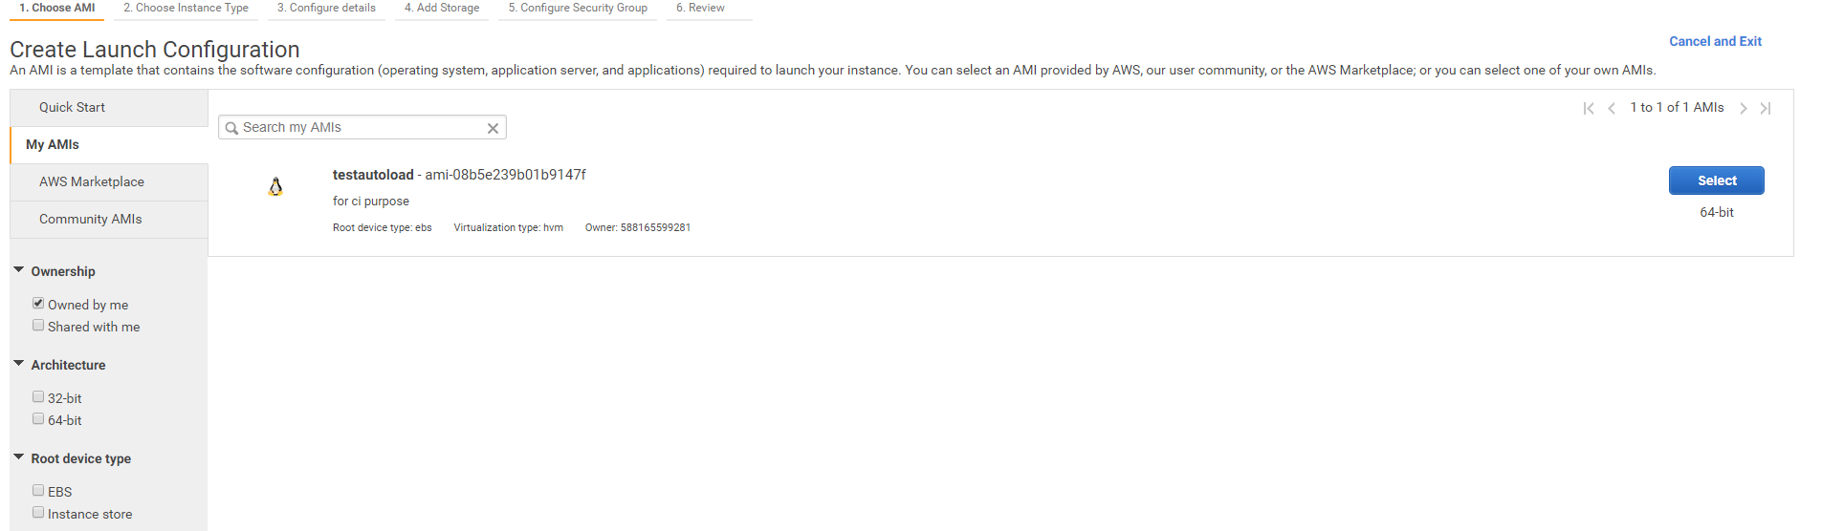

Step b: Now, we choose the instance type.

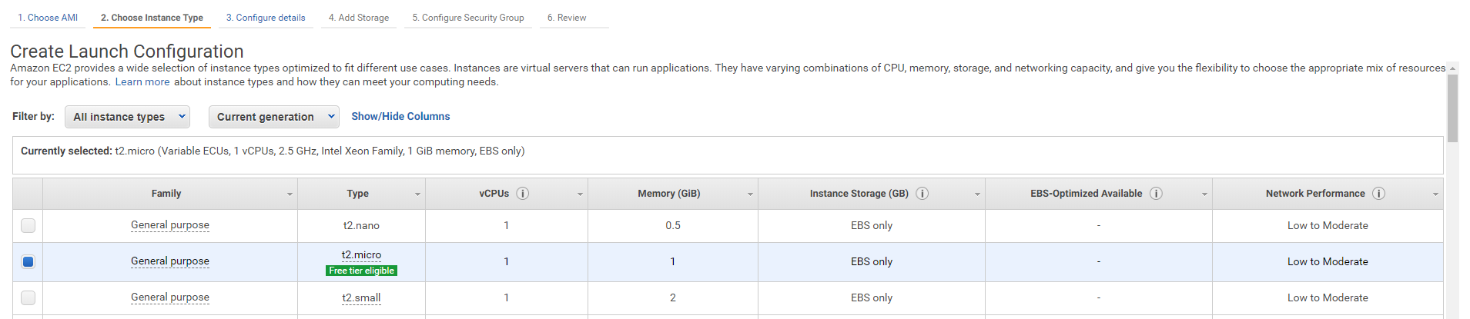

Step c: Now, we create launch-configuration (name, purchase option, IAM role, Monitoring).

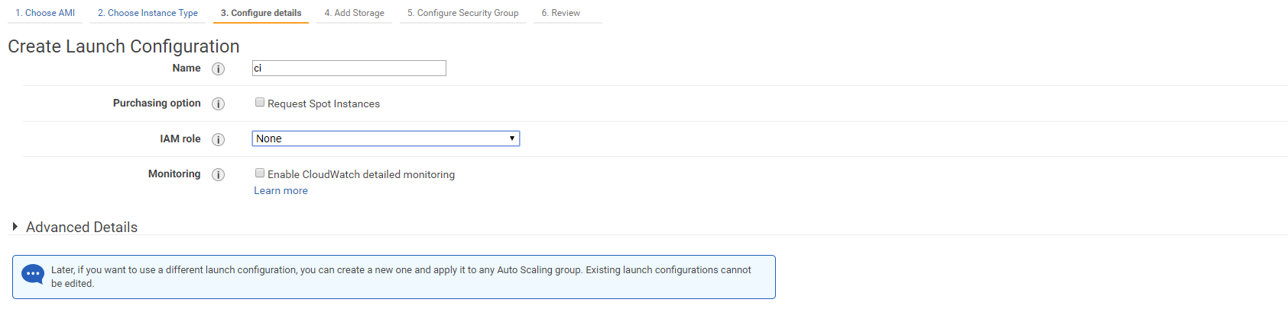

Step d: Now, we add launch configuration storge.

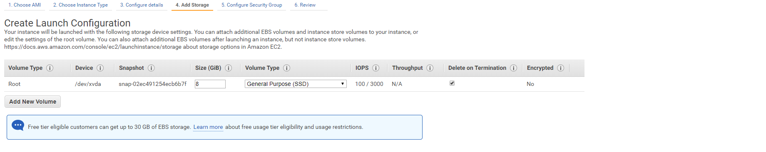

Step e: Now, we choose the security-group

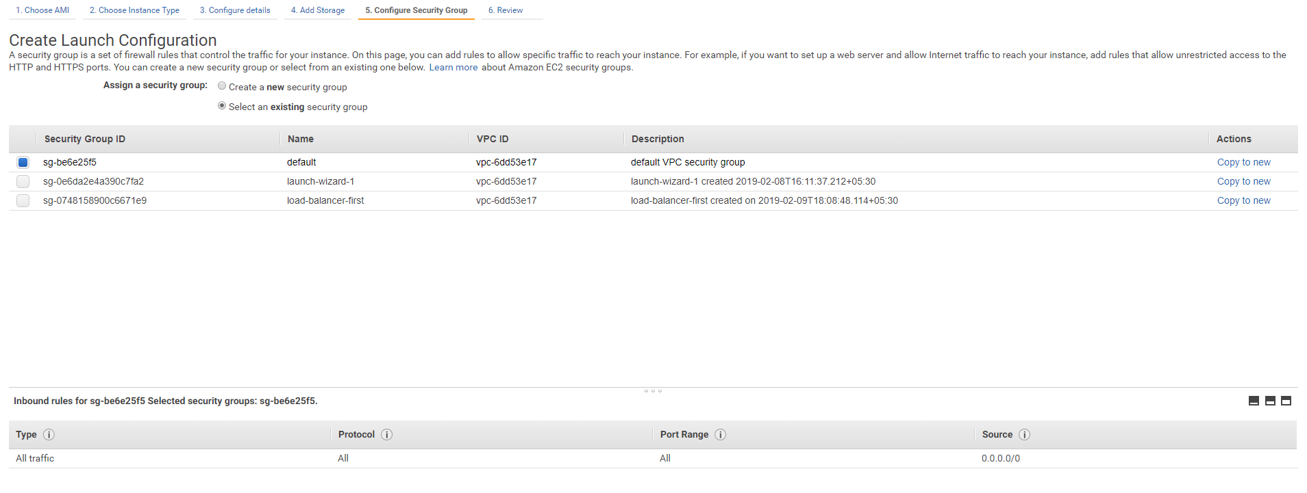

Step f: Now, we click on review then select the key-pair click on create launch-configuration.

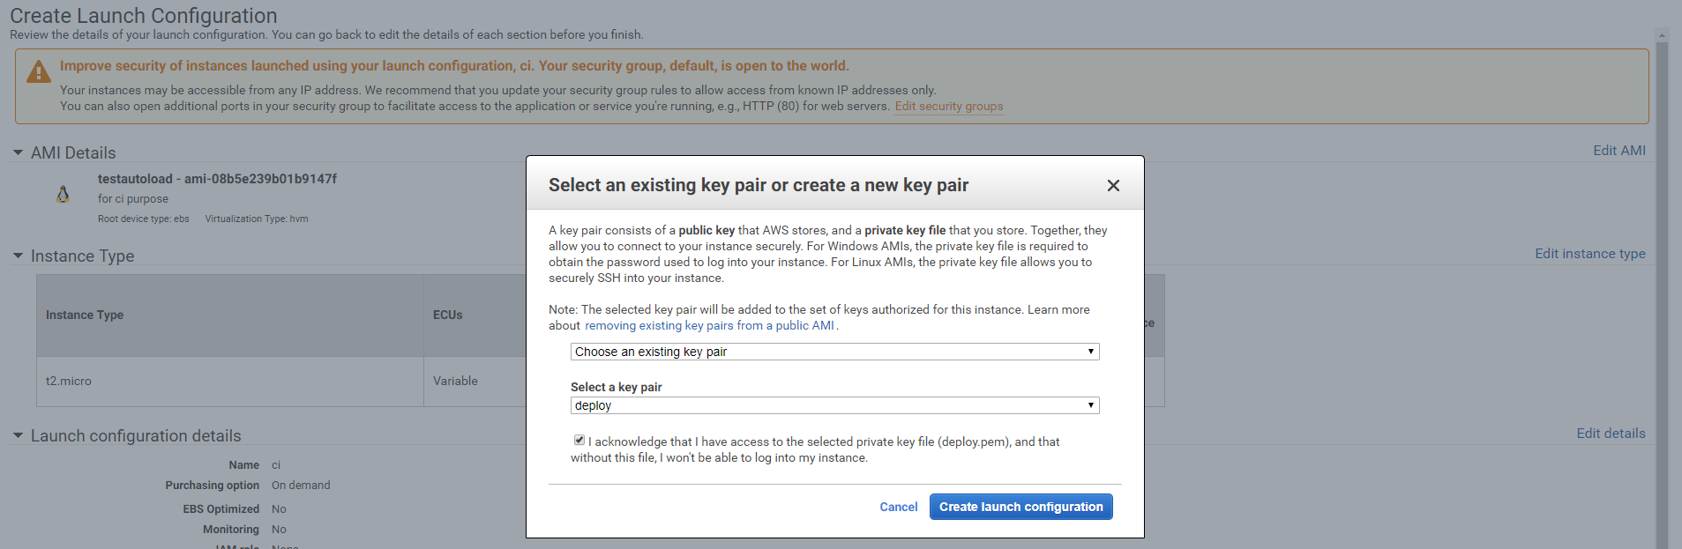

After creation of Launch-configuration we will get below pop window

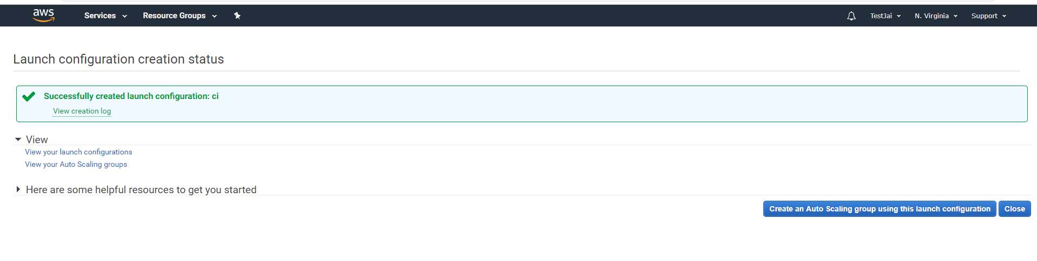

Step 3: Now, we will create the Auto-scaling group, click on auto-scaling-groups then select create auto-scaling –group . Click on create auto scaling group. Click on next step

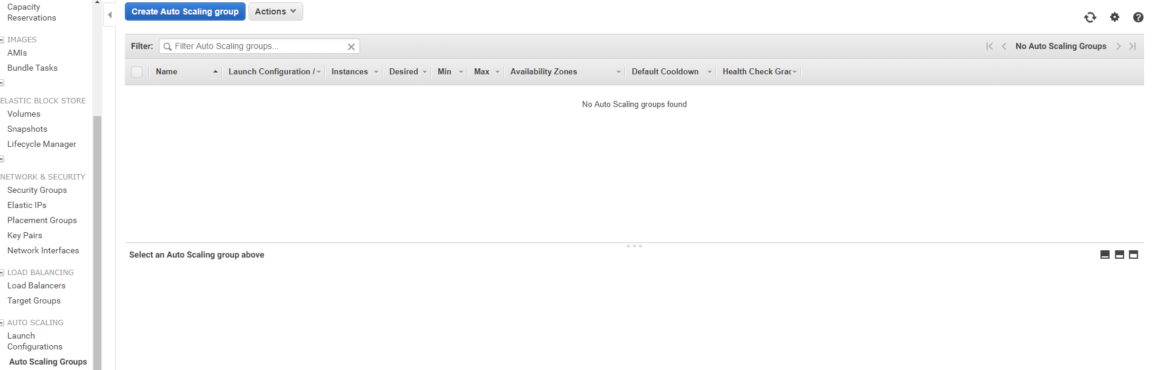

Step 3.1: First, choose either a launch-configuration or launch template to specify the parameters that parameters that your auto scaling groups uses to launch instances.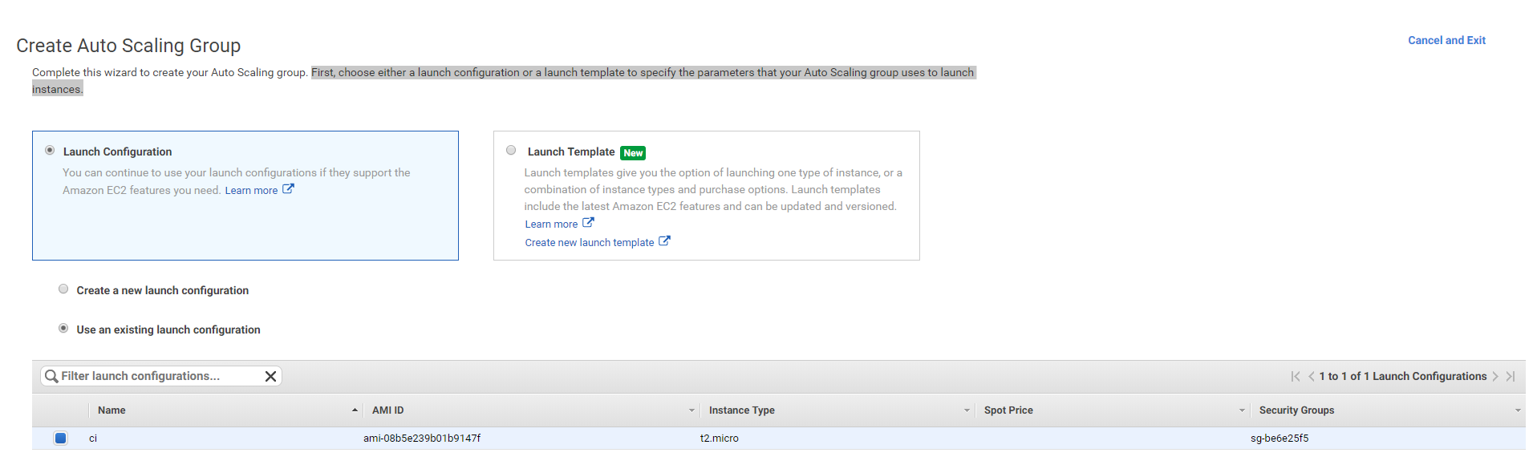

Step 3.2: Now, we configure the auto scaling group (group name, launch configuration, group size, network, subnets). Next click on configuration scaling policies.

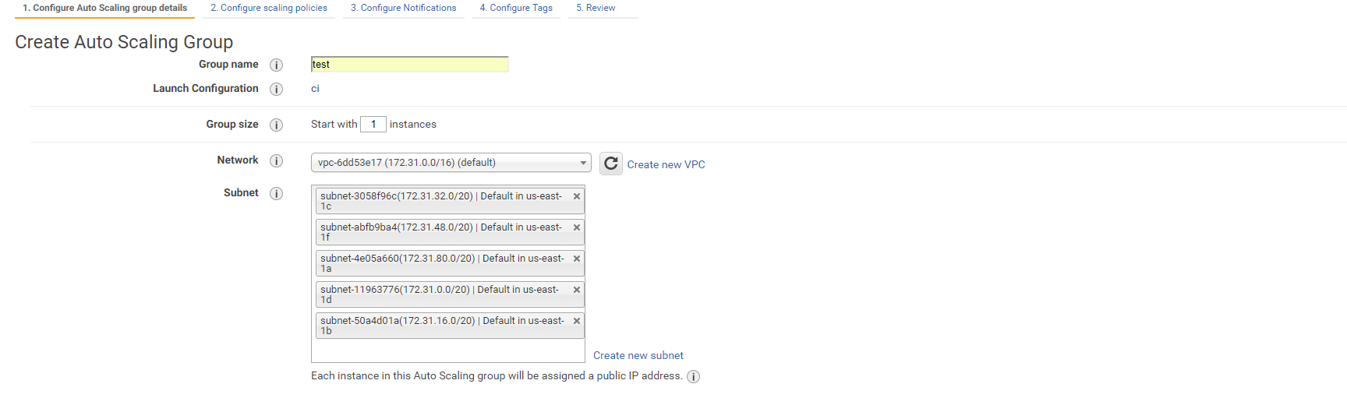

Step 3.4: Now, we set the scaling policies select the second option

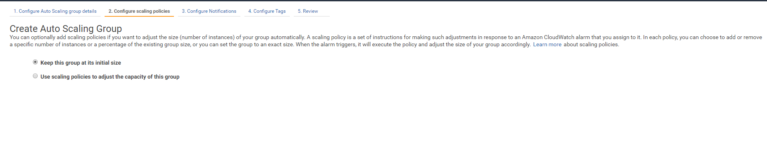

 Use scaling policies to adjust the capacity of this group, click to scale the auto scaling using step or simple scaling policies

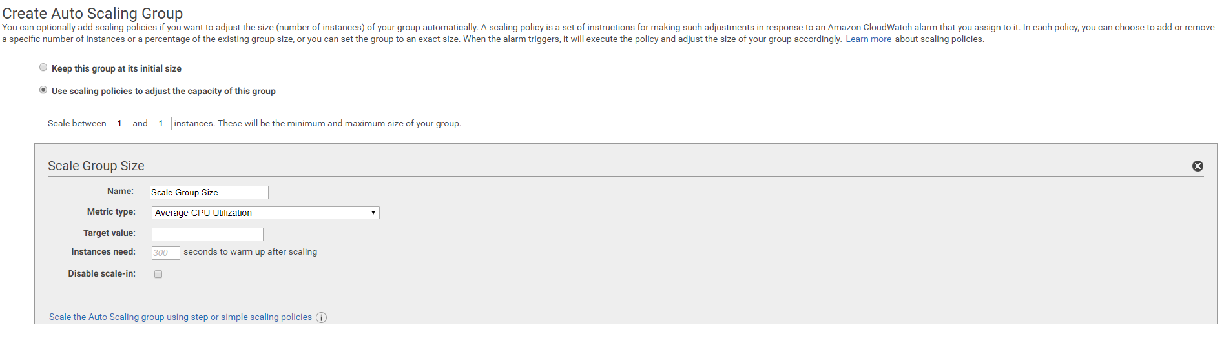

Now, we set the minimum and maximum no of instances.

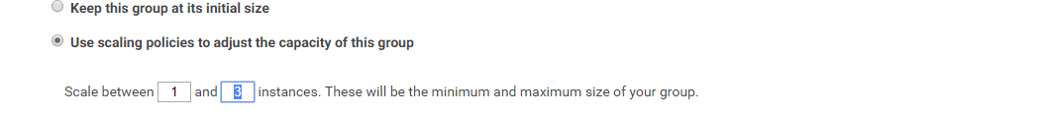

Now we are adding the alarms increasing and decreasing instances, click

Scale-up:

Set new alarm:

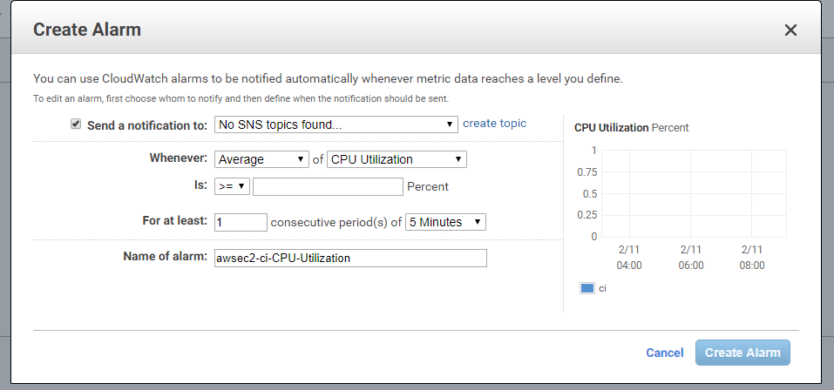

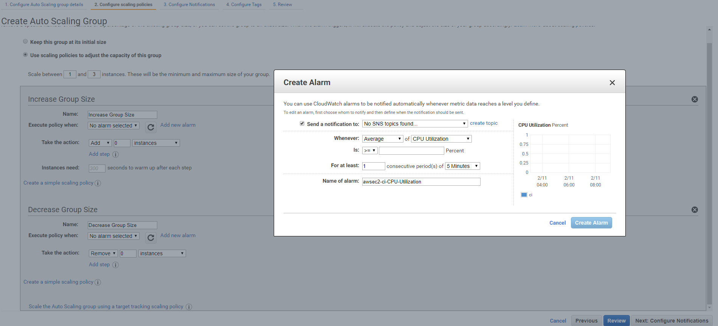

Scale-down:

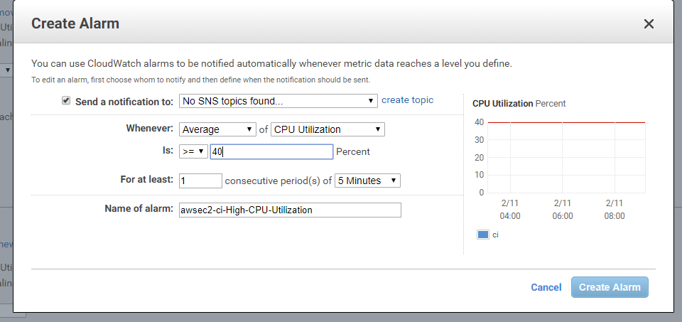

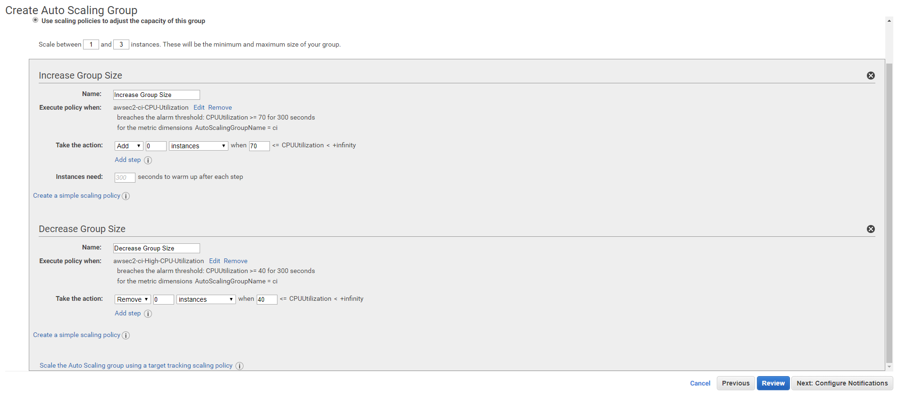

Step 4: Add the tag name click on review

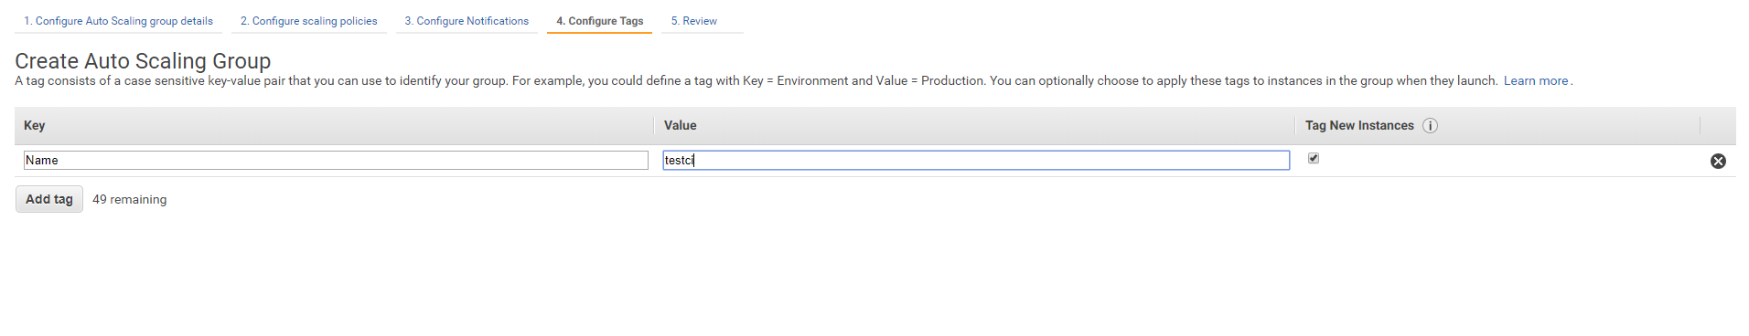

Step 5: Review the all configurations then click on create auto scaling group

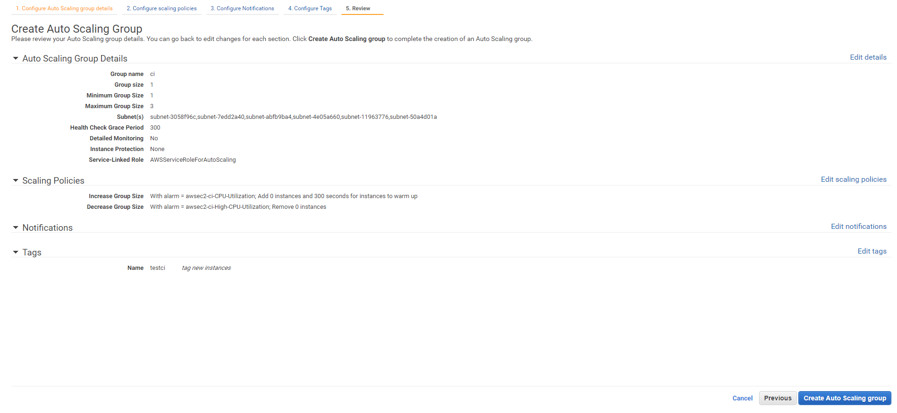

Auto scaling group dash board:

